1. A black text on a white background

   Description automatically generated
2. 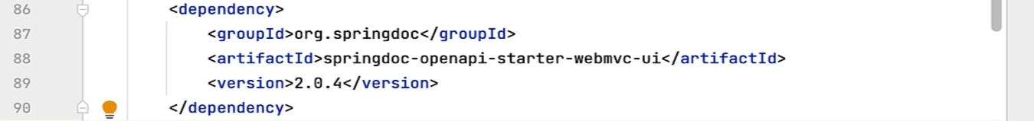
3. A screenshot of a computer

   Description automatically generated
4. 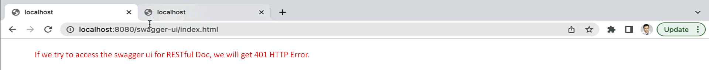  
   
5. Using Spring Security, we need to give public access to those two URLs.
6. A screenshot of a computer code

   Description automatically generated
7. A screenshot of a computer

   Description automatically generated  
     
   A screen shot of a computer

   Description automatically generated  
     
   A screenshot of a computer code

   Description automatically generated  
     
   Now trying to access   
   A screenshot of a computer

   Description automatically generated  
   A close up of a line

   Description automatically generated